PD Session #11 Poster and PowerPoint Creation

Speaker: Ms. Pam Truesdell, RET Engineering Resource Person
Date: Tuesday, July, 9, 2019
Time: 9:00-11:00 am
Venue: University of Cincinnati, Baldwin Hall, room 741

Prepared by:
Matthew Bagazinski, Detroit Cristo Rey High School, Detroit, Michigan
RET Participant for Project #3: “Bio-Inspired Optimization”
Pamela Truesdell hosted the workshop on Poster and PowerPoint Presentation in Baldwin, room 741, on Tuesday July 11, 2019. Ms. Truesdell is the Engineering Education Resource Person for the Research Experience for Teachers (RET) program, providing her guidance and expertise in teaching Engineering at the secondary level. She taught in Cincinnati Public Schools for 30 years, teaching history, mathematics, computer science, and engineering. In 2011, she was selected for the Albert Einstein Distinguished Educator Fellowship program, and she served two years at the National Science Foundation (NSF) working on the RET program in the Engineering Directorate. She also authored a short format book, Engineering Essentials for STEM Instruction: How do I infuse real-world problem solving into science, technology, and math? (ASCD Arias), which was co-released by ASCD and NSTA Press in April, 2014.
Ms. Truesdell began her session discussing the importance of keeping the audience in mind while creating a poster or presentation. The primary audience includes the judges, current and former RET teachers, and administrators; the poster will have a secondary audience of students, parents, and colleagues at the RET teacher’s school. Posters have the primary focus of demonstrating how the summer research will be taken to the classroom, through the Challenge Based Learning principles and the Engineering Design Process. In Figure 1, Ms. Truesdell is shown stressing the importance of keeping the audience in mind, and Figure 2 shows the objectives of the workshop.

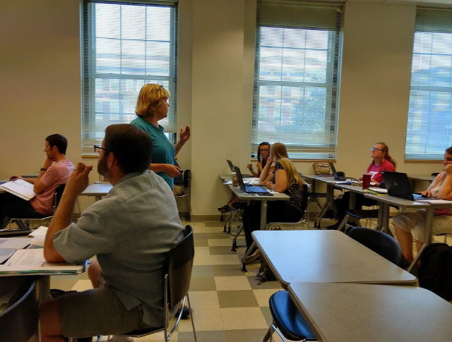  Figure 1: Emphasizing the Importance of the Audience | 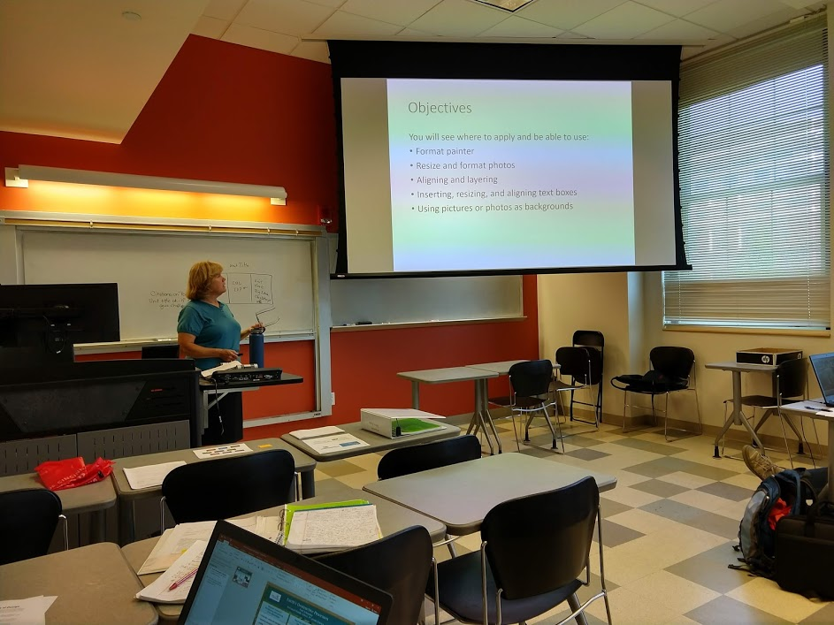  Figure 2: Sharing the Objectives

Ms. Truesdell went over the summer poster requirements: inclusion of the NSF logo and RET project grant number, inclusion of the University of Cincinnati logo, inclusion of RET teacher’s school or district logo, and the RET teacher’s name, school name, and subject taught. All of these should be part of the top banner. The poster must be broken into three sections, highlighting the research done over the summer, the connection to the RET teacher’s classroom, and the design challenge for the RET teacher’s classes. Fonts need to be at least size 28, and the balance of pictures and whitespace is crucial.

After the requirements, Ms. Truesdell went over the principles and elements of design: unity and variety, emphasis and focal point, scale and proportion, balance, rhythm, line, shape and volume, texture and pattern, illusion of space, illusion of motion, value, and color. RET participants were shown posters that exemplified these elements or a lack thereof and were asked to identify what was present or missing.
Throughout, Ms. Truesdell gave tips and pointers to using PowerPoint for both making a poster and a presentation. One highlight was a tool called Format Painter; this allowed participants to select a section of their poster or presentation that had a desirable format, then simply apply to other sections to match the formatting (font, font size, spacing, etc.) without changing the content of either section. Another helpful tool was the Remove Background feature; this allowed participants to make sections of an image invisible, so the rest of the slide would show through as the background.
Finally, Ms. Truesdell included an activity where we pointed out the errors in a sample poster and fixed them. RET participants were eager to point out all of the aspects that needed to be fixed and were able to identify the tools best suited to fix them.

